CFD SIMULATION OF TURBULENT WATER FLOW THROUGH A PARTIALLY OBSTRUCTED 2D PIPE USING COMSOL MULTIPHYSICS

Names | UGWOKE KENECHUKWU PERFECTUS
Reg. No | 2022/241806
Experiment No | 6
Group No. | 4

Objective of Experiment / Simulations

The objective of this simulation is to model and analyze the steady incompressible turbulent flow of water through a two-dimensional pipe containing a geometric obstruction. Specific goals:
1. Compute velocity and pressure fields around the obstruction and in the downstream wake.
2. Evaluate turbulence behavior using the RANS k–ε turbulence model and inspect derived turbulence quantities (k, ε).
3. Extract point values and assess solver convergence and mesh quality.

Theory/Background

The flow is governed by the fundamental laws of conservation of mass and momentum.
Governing Equations:
For an incompressible, turbulent flow, the Reynolds-Averaged Navier-Stokes (RANS) equations are used:
Continuity Equation (Conservation of Mass):
∇⋅u=0∇⋅u=0
Momentum Equation (Conservation of Momentum):
ρ(u⋅∇)u=∇⋅[−pI+(μ+μT)(∇u+(∇u)T)]+Fρ(u⋅∇)u=∇⋅[−pI+(μ+μT​)(∇u+(∇u)T)]+F
Where:
- u is the Reynolds-averaged velocity vector (m/s),
- ρ is the fluid density (kg/m³),
- p is the pressure (Pa),
- μ is the dynamic viscosity of the fluid (Pa·s),
- μT is the turbulent viscosity (Pa·s),
- I is the identity tensor,
- F represents body forces (N/m³).
The Standard k-ε Turbulence Model
The turbulent viscosity μTμT​ is modeled using the standard k-ε (k-epsilon) model, which introduces two additional transport equations for the turbulent kinetic energy kk and its dissipation rate ϵϵ.
Turbulent Kinetic Energy (k) Equation:
ρ(u⋅∇)k=∇⋅[(μ+μTσk)∇k]+Pk−ρϵρ(u⋅∇)k=∇⋅[(μ+σk​μT​​)∇k]+Pk​−ρϵ
Turbulent Dissipation Rate (ε) Equation:
ρ(u⋅∇)ϵ=∇⋅[(μ+μTσϵ)∇ϵ]+Cϵ1ϵkPk−Cϵ2ρϵ2kρ(u⋅∇)ϵ=∇⋅[(μ+σϵ​μT​​)∇ϵ]+Cϵ1​kϵ​Pk​−Cϵ2​ρkϵ2​
The turbulent viscosity is calculated as:
μT=ρCμk2ϵμT​=ρCμ​ϵk2​
The standard model constants used in this simulation are:
- Cμ=0.09Cμ​=0.09
- Cϵ1=1.44Cϵ1​=1.44
- Cϵ2=1.92Cϵ2​=1.92
- σk=1.0σk​=1.0
- σϵ=1.3σϵ​=1.3

Wall Treatment
The simulation employed Wall Functions to model the flow near the pipe and obstruction walls. This approach applies empirical formulas to bridge the viscous sublayer, avoiding the need for an excessively fine mesh at the walls, which is computationally expensive. The standard wall function based on the law of the wall was used with a constant B=5.2B=5.2.

Procedure (Step-by-step)

I set up and executed the simulation in COMSOL Multiphysics following this procedure:
- Global Definitions:
  - Parameters such as pipe diameter (D = 0.08 m), length (L = 0.86 m), obstruction dimensions, and inlet velocity (U = 5 m/s) were defined.
- Geometry Modeling (Component 1):
  - I created a 2D rectangle to represent the pipe.
  - I added obstructions using additional rectangles and a Bézier polygon to create a triangular shape or streamlined obstruction followed by a thin plate.
  - I defined probe points for later result evaluation (Point 5 and Point 10).
- Material Properties:
  - I selected water as the working fluid.
  - I imported temperature-dependent properties (density ρ, viscosity μ, heat capacity Cp​, thermal conductivity k) from COMSOL's built-in material library. I assumed a constant temperature of 293.15 K.
- Physics Setup (Turbulent Flow, k-ε):
  - I selected the k-ε turbulence model with wall functions for the fluid domain.
  - Boundary Conditions:
    - Inlet: I specified a normal inflow velocity of 5 m/s. I set turbulent intensity to 5% and I used a turbulent length scale of 0.01m to initialize k and ε.
    - Walls: I applied no-slip condition to all walls and obstructions.
    - Outlet: I set a pressure condition with p = 0 Pa (gauge pressure), with backflow suppression enabled.
- Meshing (Mesh 1):
  - I generated a physics-controlled mesh, calibrated for fluid dynamics.
  - Boundary Layers: I applied five boundary layers with a total thickness factor of 2.5 to all walls to accurately capture the high velocity gradients in these regions.
  - Local Refinement: I significantly refined element size on the walls (max size: 2.24e-3 m) and on the overall domain (max size: 3.6e-3 m) compared to the pipe diameter.
  - The final mesh consisted of 25,816 elements (21,520 triangles, 4,296 quadrilaterals) with an average quality of 0.8172.
- Study Configuration:
  - I executed a stationary study.
  - I used a segregated approach in the solver:
    - Group 1: Velocity and Pressure equations, solved with a direct (PARDISO) solver and a damping factor of 0.5.
    - Group 2: Turbulence (k and ε) equations, solved with a direct (PARDISO) solver, a damping factor of 0.35, and 3 iterations per segregation step.
  - I used pseudo time-stepping for convergence acceleration. The solver converged after 218 iterations in 11 minutes and 28 seconds.
- Post-Processing:
  - Results were visualized using surface plots for velocity magnitude and contour plots for pressure.
  - I used derived values to evaluate pressure at the predefined probe points created earlier.

Result & Discussion
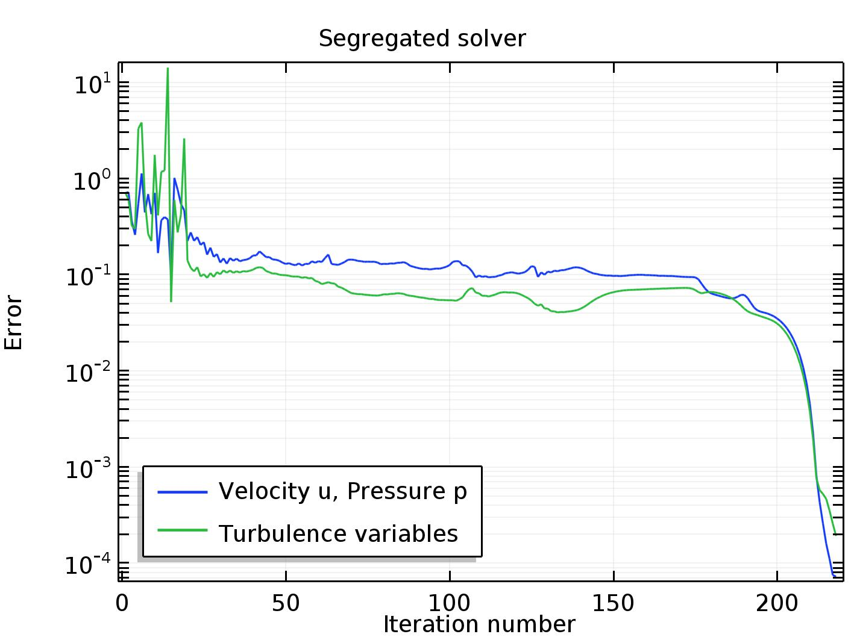
Convergence Plot

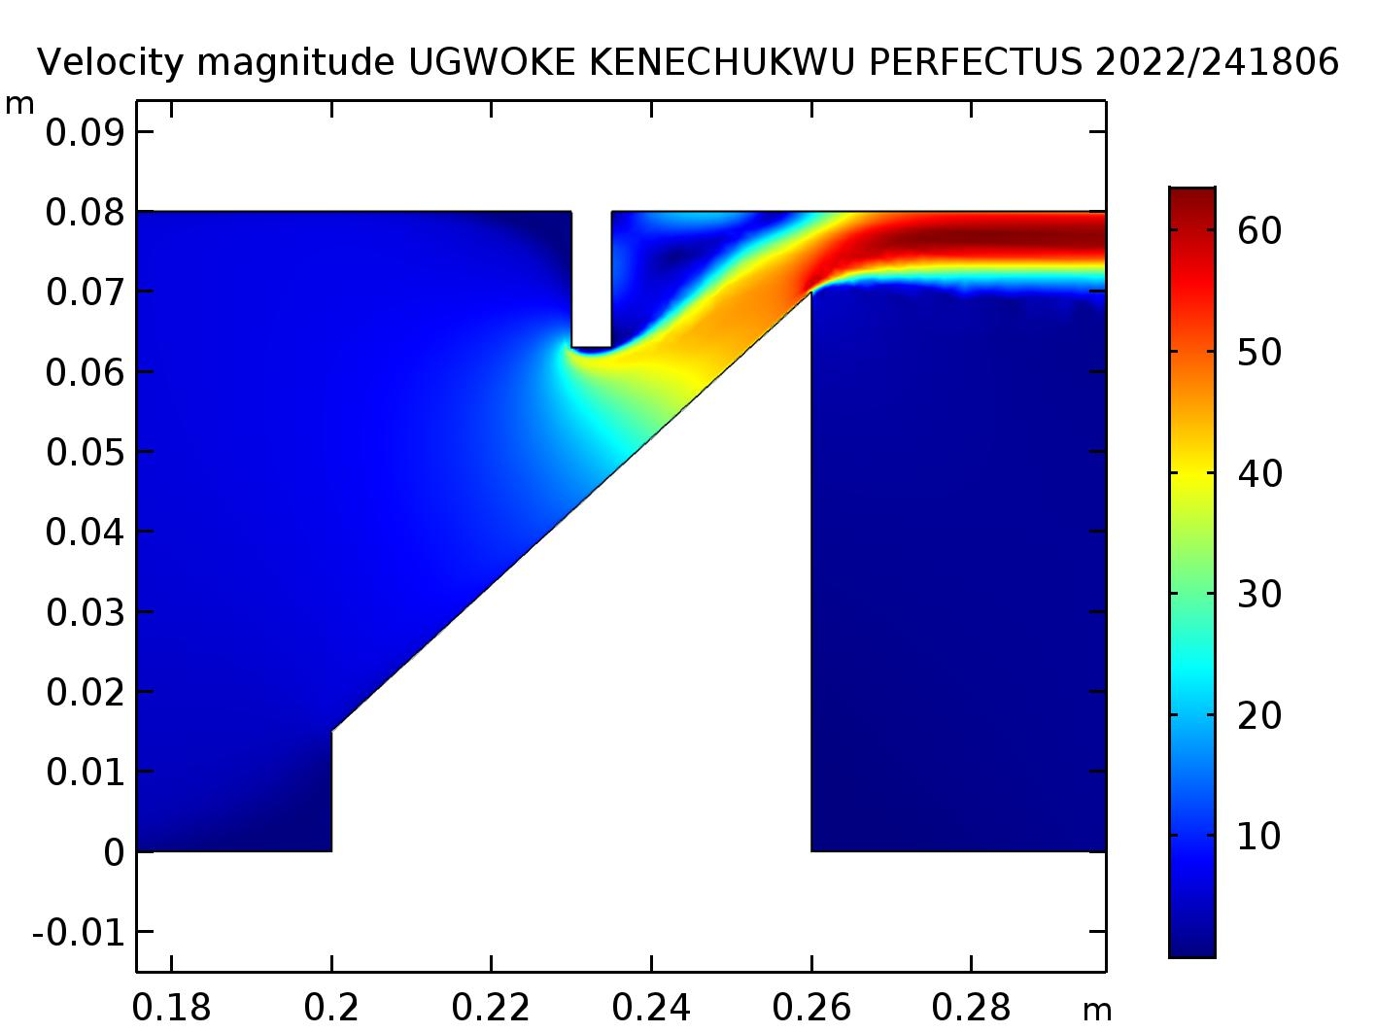
Velocity Surface

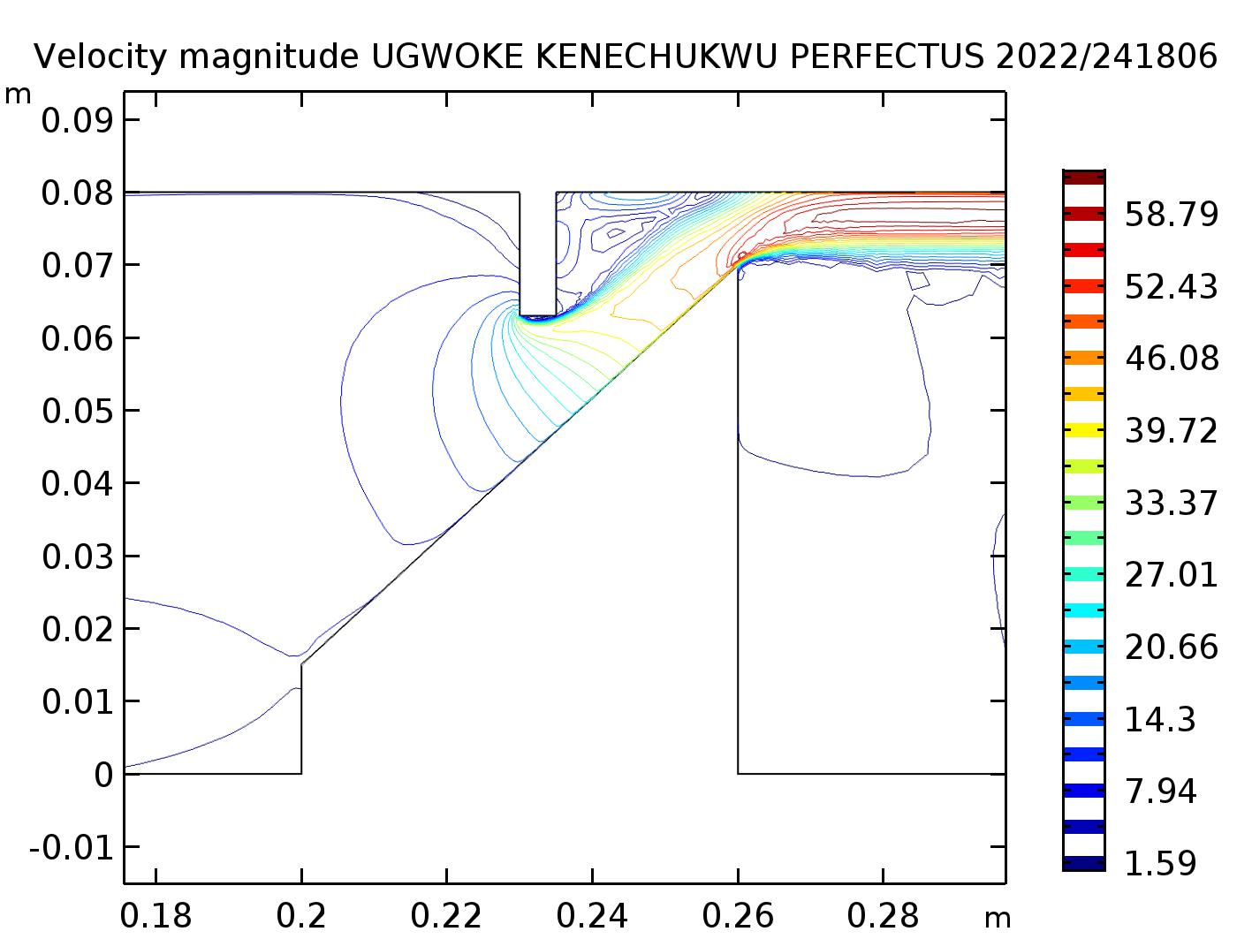
Velocity contour

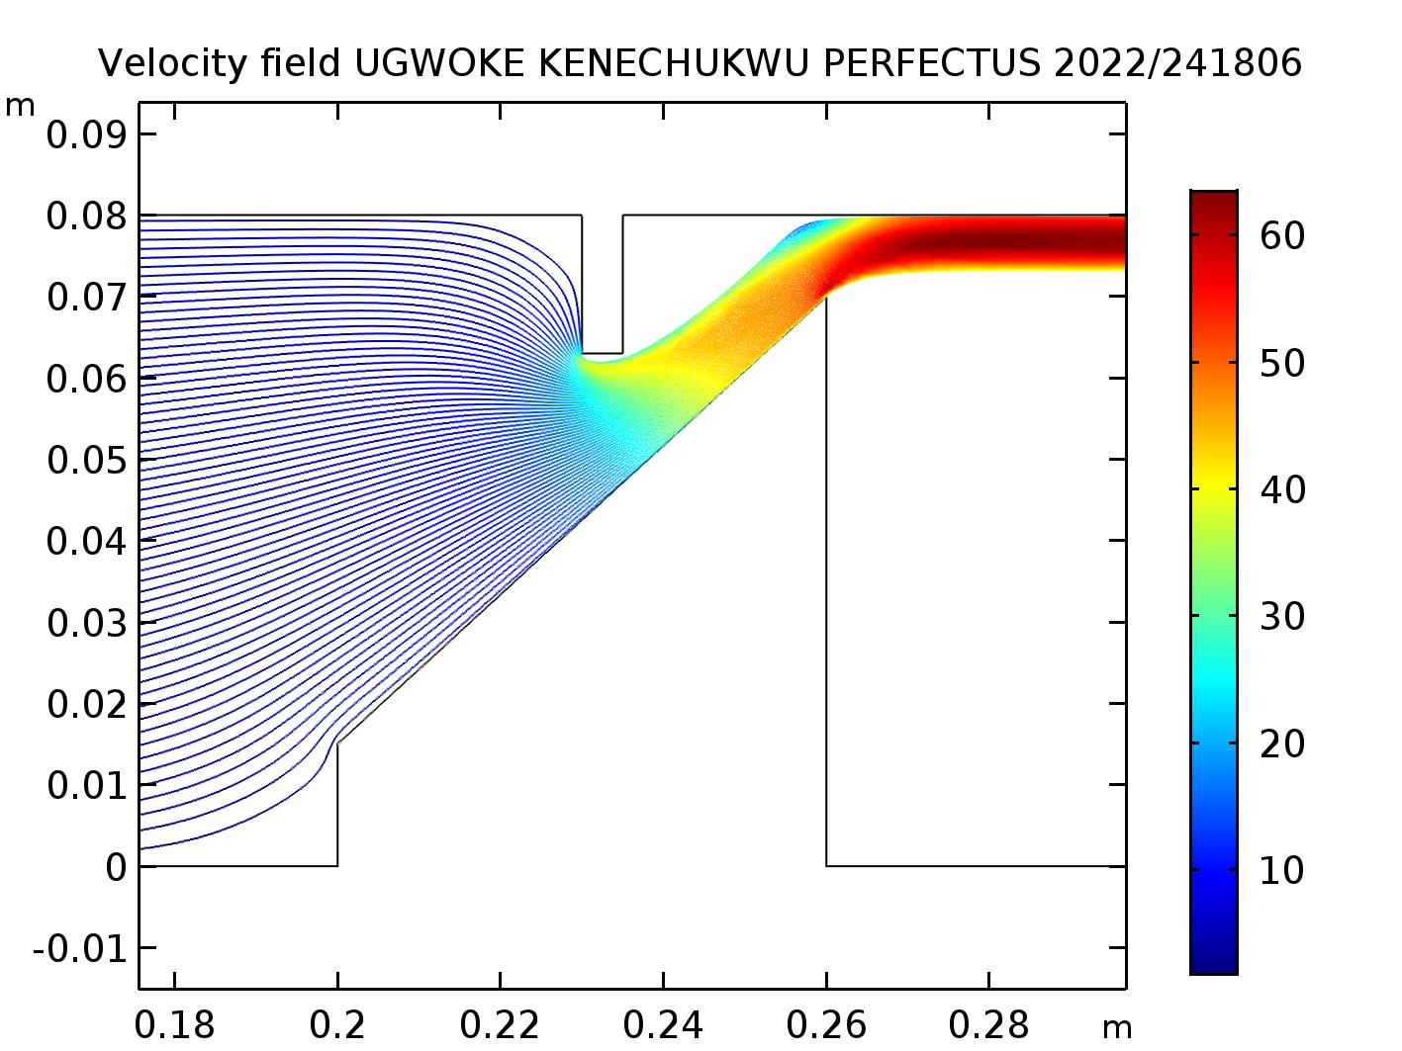
Velocity streamline

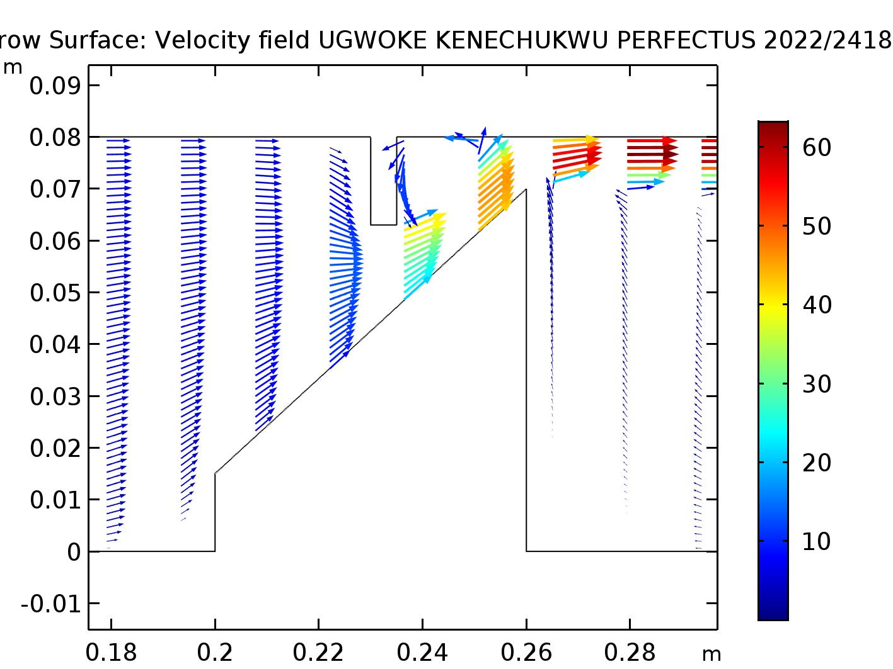
Velocity arrow surface

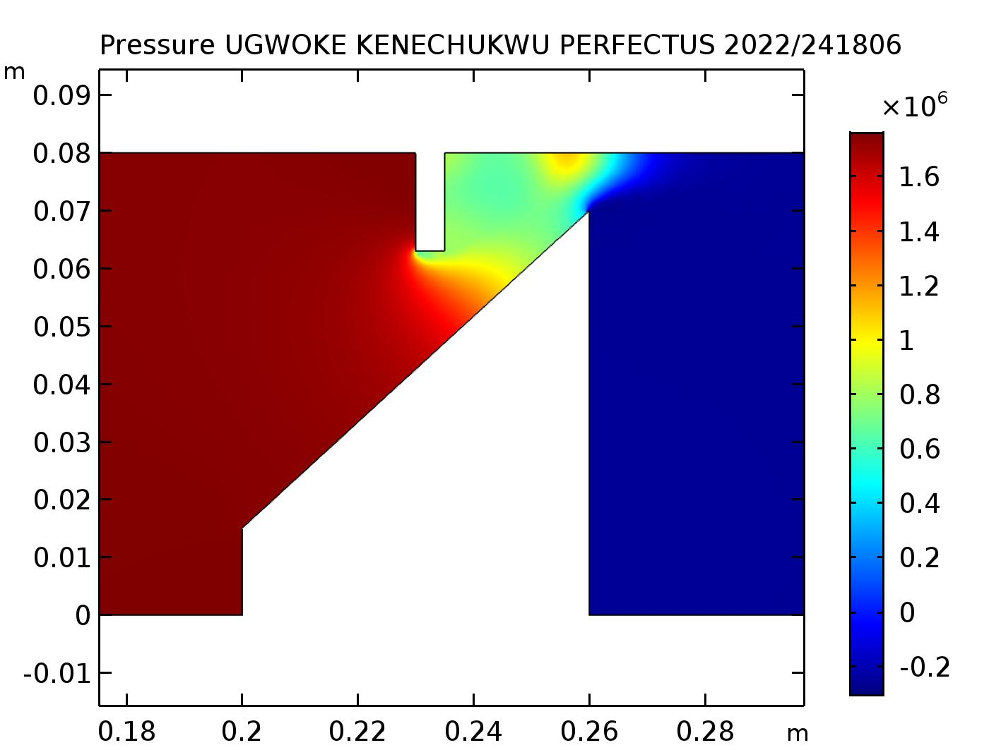
Velocity Pressure surface

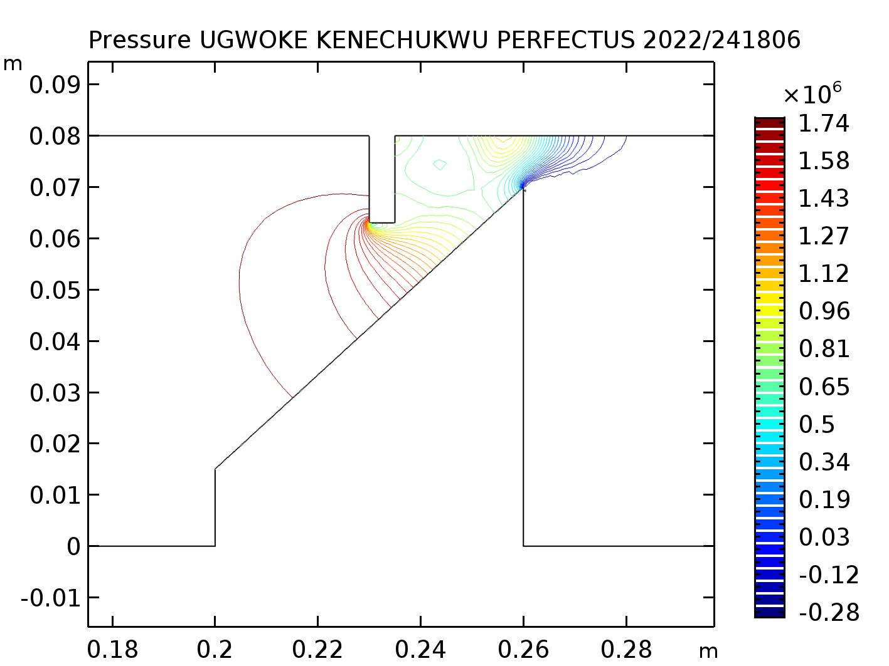
Pressure contour

Flow Field Visualization
- Velocity Field: The surface plot of velocity magnitude shows expected flow behavior. The flow accelerates as it converges between the obstruction and the pipe wall, reaching a maximum velocity higher than the inlet 5 m/s. A recirculation zone (wake region) with low velocity is evident immediately downstream of the obstruction, which is a classic characteristic of flow past a bluff body.
- Pressure Field: The contour plot reveals a high-pressure region at the front (upstream face) of the obstruction where the flow impinges. A low-pressure region forms at the top of the obstruction and in the wake due to flow separation and acceleration. The pressure gradually recovers downstream.
Quantitative Pressure Analysis
The pressure was evaluated at two points to quantify the pressure drop across the obstruction.
Point 5 (P_5) is located upstream of the obstruction
Point 10 (P_10) is located downstream of the obstruction.
- Point 5 Pressure: 1.745 × 10^6 Pa
- Point 10 Pressure: 6.601 × 10^5 Pa
Pressure Drop (ΔP):
ΔP = P_ 5 – P_10 = 1.745E6 - 6.6012E5 = 1.08488×10⁶ Pa
This significant pressure drop (over 1 MPa) is a direct result of the energy losses associated with overcoming the form drag of the obstruction and the viscous dissipation within the turbulent wake.
4.3 Mesh and Solver Performance
- The use of boundary layers and local mesh refinement was crucial for resolving the steep gradients near the walls without making the global mesh prohibitively large.
- The solver log shows a stable convergence history. The error estimates for both the velocity-pressure group and the turbulence group decreased monotonically over 218 iterations. The pseudo time-stepping algorithm successfully increased the CFL number from an initial value to 1, facilitating convergence. This indicates a well-posed model and a robust solver configuration.
4.4 Implications
The results confirm that obstructions in a flow path cause significant flow disturbances, leading to:
- Increased Energy Consumption: A large pressure drop requires more pump power to maintain the desired flow rate.
- Mixed Flow Patterns: Areas of high shear and recirculation can lead to vibrations, potential cavitation (in liquids), and increased mixing.
- Erosion Potential: The impingement of high-velocity flow on the obstruction and the pipe wall downstream can lead to material erosion over time.

Conclusion
The simulation successfully met its objectives. The turbulent flow of water through an obstructed 2D pipe was accurately modeled using the RANS-based k-ε model in COMSOL Multiphysics. The results provided detailed insights into the velocity and pressure distributions, clearly showing flow acceleration, separation, and wake formation. A substantial pressure drop of approximately 1.085 MPa was quantified across the obstruction, highlighting its significant impact on flow energy loss.
Recommendations for Further Studies:
- Transient Analysis (LES/DES): Employ a Large Eddy Simulation (LES) or Detached Eddy Simulation (DES) to capture the transient, large-scale turbulent structures in the wake more accurately than the steady-state RANS approach.
- Parametric Study: Investigate how the pressure drop and flow behavior change with varying obstruction geometry, inlet velocity, or pipe diameter.
- Heat Transfer: Introduce heat transfer to analyze the thermal effects on the flow and the temperature distribution around the obstructions.
- Acoustic Analysis: Use the flow results as a source for a subsequent acoustic simulation to predict the noise generated by the flow past the obstructions.
- Mesh Independence Study: Formally verify that the results are independent of the mesh density by comparing solutions on progressively finer meshes.

